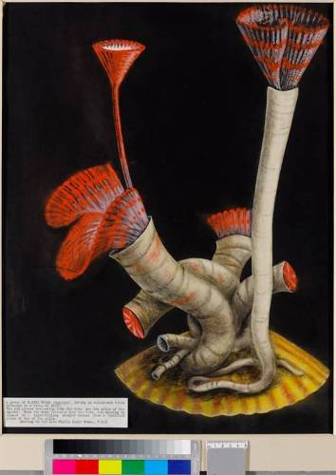

Philip Gosse, ‘Marine Worms’ c1850
A group of marine worms (serpula), living in calcareous tubes attached to a piece of shell. The red plumes projecting from the tube are the gills of the animal. When the worm retreats into the tube, the opening is closed by a tight fitting stopper formed from a modified piece of one of the gills.
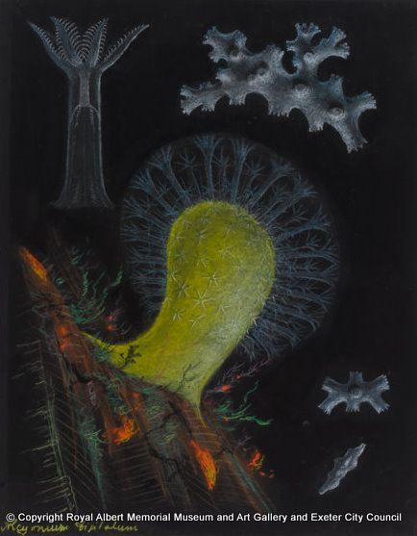
Philip Gosse,’Coral: dead man’s fingers’.
This soft-coral, commonly known as ‘dead mans fingers’ is attached to a piece of rock.

Philip Gosse, Marine worms: serpula
A group of marine worms (serpula), living in calcareous tubes attached to a piece of shell.

